# 3. Approach proposed for the implementation phase

You’ve told us that you want to do more than just implement a new HR system; you want to transform how you work. To meet Technicolor’s long-term’s objectives, we’ve adjusted our approach to meet this goal.

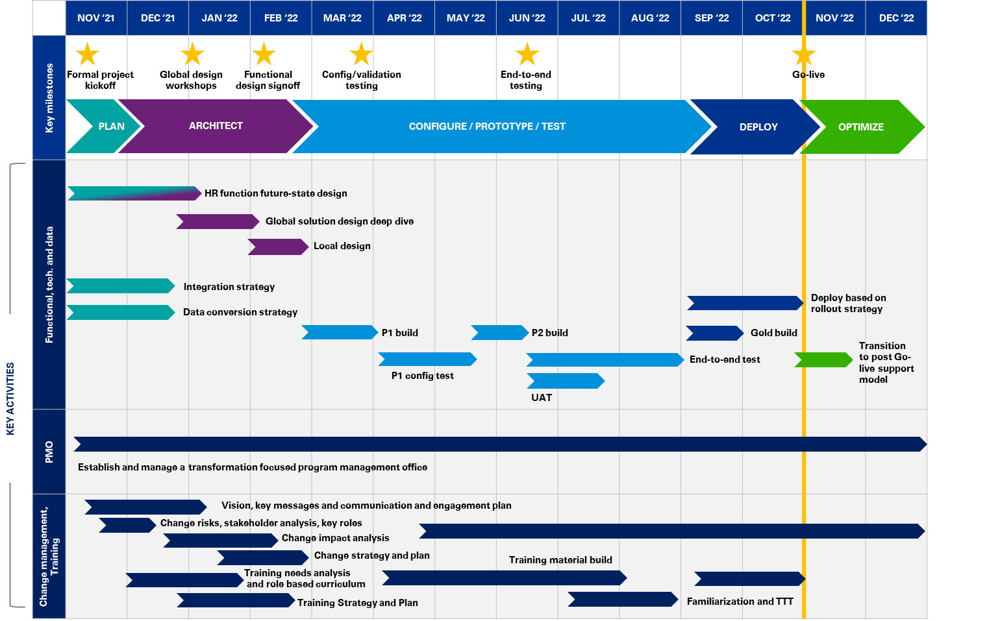**Timeline**

We propose a one-year implementation project covering the full functional scope described in Phase 1 and Phase 2 (Core HR, Absence for 3 countries, HR ticketing, Compensation, Benefits for 4 countries and Talent Management). Please see Deployment options for more details on the recommended planning.

We welcome the opportunity to work with you to shape it to your exact needs and resource availability. For the purposes of this document, this sequence and timing represents our vision for how we can help you extract the most value from your Workday implementation. Our Powered Enterprise solution will enable Technicolor to make better, faster, decisions, resulting in an accelerated path to your transformation.

Please see **Appendix A** for the detailed project plan.

As noted in the timeline on the previous page, the Powered Enterprise methodology is comprised of five stages: Plan, Architect, Configure/Prototype/Test, Deploy and Optimize. Each are described below.

|  |  |  |  |  |
| --- | --- | --- | --- | --- |
| A. Plan | B. Architect | C. Configure/ Prototype/Test | D. Deploy | E. Optimize |
| Launch the project and align key stakeholders on key design principles | Align and finalize the to-be design, develop a plan for implementation and finalize the solution design | Build and test the technology solution and design layers using an iterative testing process and prepare for deployment | Conduct User Acceptance Testing (UAT), deploy solution and its relevant components and deliver training to end users | Complete post go-live support and project closure procedures |



## Plan stage

The primary objectives of the Plan phase are to define the overall project scope and to develop the procedures and mechanisms required to plan and control the project. This phase sets the overall direction and approach for managing the project and is critical to its success.

### Scope management

Establishing, monitoring and controlling the work can be one of the most difficult areas to properly address for program managers.

Techniques used for scope management include clearly documenting the scope in the initial contract and validating it during the Plan Stage. Throughout the project, the PMO will closely monitor any requested changes that deviate from the baseline scope. Through our change control process, requested changes will be reviewed from both a risk, timeline and effort/cost perspective with Technicolor to fully assess impact and level of importance.

Any changes to scope will require approval from both KPMG and Technicolor leadership.

### Current state diagnostics and vision

During Planning, we will create a detailed integrated project plan as project scope, activities, and dates become more certain. We will continually monitor the approved project plan to determine progress throughout the project. Regular Steering Committee meetings will serve as status checkpoints with project leadership, and schedules will be reviewed and revised as agreed on a regular cycle.

### Summary of Plan activities and deliverables:

| Key activities | Deliverables/outcomes |
| --- | --- |
| * Provide assessment of existing HR system landscape * Begin change management work to understand existing conditions * Develop key materials to guide project * Strategic document development for data and integrations | * Target Operating Model assessment (O) * Vision & Case for Change (D) * Stakeholder analysis (D) * Project plan (D) * Resource plan (D) * Backfill plan(D) * Tenant management strategy (D) * Data conversion strategy (D) * Integration strategy (D) * Integration inventory (D) * Data Gathering Workbook (D) |

*D= Deliverables O = Outcomes*

## Architect stage

During the Architect stage, we propose a HR transformation approach that not only focuses on system design but also, on defining the future-state HR organization ensuring greater design and experience consistency.

**1. HR organization future-state design**

Definition of high-level processes, roles and responsibilities and organization principles, ensuring transversal consistency across streams

**2. Global solution design and deep dives**

Global design workshops by domain, deep diving into detailed processes, configuration, and data. This phase’s purpose is to build a robust core model, scalable for localization and any future organization scope extension

**3. Local design**

Localization workshops will allow to engage local stakeholders in the identification of the gaps with the core model based on local legal regulation and key business specificities

Nov.-Dec. ‘21

Jan.-

Feb, ‘22

Feb. ‘22

### HR function future-state design

This project isn’t only about implementing a new technology; it’s about transforming how you work and interact within the HR function and with employees and managers. Therefore, we propose to conduct HR function future-state design at the beginning of the project.

In alignment with the recent Technicolor’s HR function transformation, the purpose of this phase is to:

* **Share a common vision** across the HR domains in scope of this project
* **Ensure** **consistency** from an end-to-end perspective across the HR processes to secure touchpoints
* **Clarify** **roles and responsibilities** for HR, managers, and employees by domain and transversally to enhance the overall people experience
* **Review and optimize the HR processes** by building a **shared core model** which will be the foundation for our global system design workshops.

Concretely, we will leverage KPMG Powered Target Operating Model best practices and templates, in alignment with our implementation method, to help you define a best-in-class HR Operating model and position your HR function as a strategic partner for business.

We propose to conduct the following activities at the beginning of the project:

Jan.’22

Dec.’21

Nov.’21

* Interviews with key stakeholders per domain
* Existing document collection and analysis
* Transversal workshop to define HR Guiding principles

Workshops by HR domain to design:

* Target people experience
* Target high-level RACI
* HR organization layers (corporate, division) purpose and key activities

Transversal workshop to define:

* Transversal roles and responsibilities for HR, managers, and employees
* Transversal HR organization layers purpose and activities

**Current state diagnostics & VISION**

**High-level design BY DOMAIN**

**CROSS-DOMAIN DESIGN**

**Global SOLUTION Design   
DEEP DIVE**  
Detailed processes (Level 5) design

This phase will serve as an input for the global system design workshops, allowing to build the foundations for the in-scope domains: Core HR, HR ticketing and knowledge management, compensation and benefits, talent management, and reporting.

#### Current state diagnostics and vision

This phase will help us gain understanding of Technicolor’s current HR operating model – organization, governance, processes, roles and responsibilities and technology – as well as identify the challenges to address and the specificities and current strengths to keep.

We propose to conduct the following activities:

* **Conduct 2-hour** **current-state interviews** with key HR stakeholders (HRD, project director) and HR Functional leads on a pre-defined and validated interview questionnaire.
* **Analyze** **existing documentation** – already formalized policies and processes, HR metrics (HR FTEs, KPIs)
* **Conduct** **a half-day** **Global workshop** with key HR stakeholders and Functional leads to:
* Restitute the current-state analysis
* Co-construct the HR Guiding principles in terms of roles and responsibilities, processes, organization, and system design. These principles will allow to:
* Drive the high-level design per domain and ensure end-to-end consistency
* Provide a reference framework to align quickly on key decisions
* Help ensure the operating model and technology design are aligned.

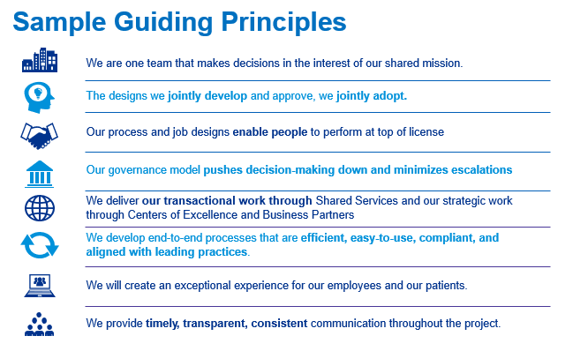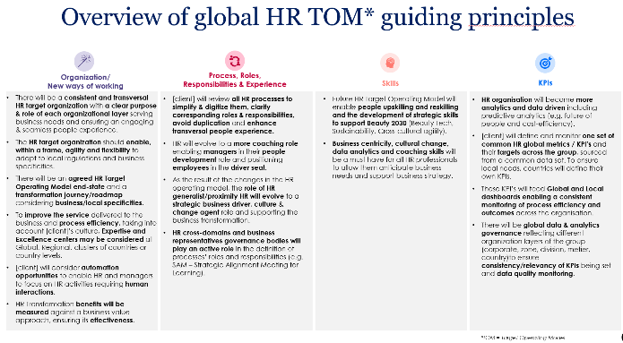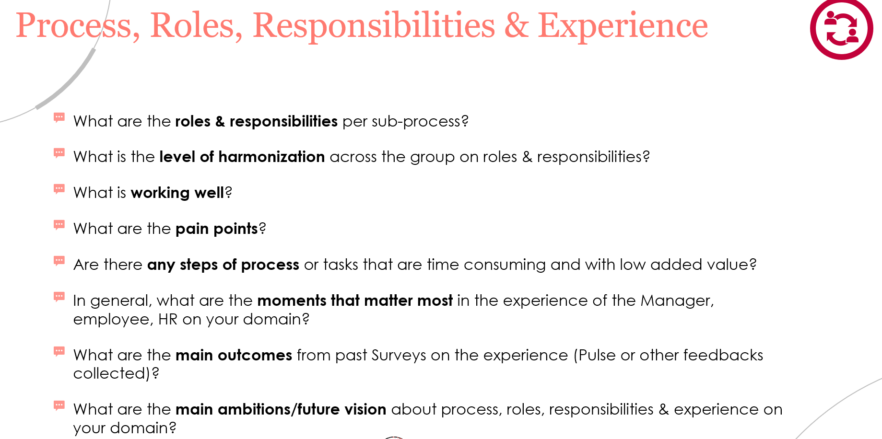 Illustration of HR Guiding Principles

Illustration of HR Guiding Principles

Illustrative questionnaire

#### High-level design by domain

In alignment with the HR Guiding Principles, we will leverage our Powered methodology leading practices and templates to build your HR organization principles, roles, responsibilities, and processes. By starting with already formalized deliverables constituting around 80 percent of the configuration, your team will be able to focus on the 20 percent of Technicolor specificities that need to be taken into consideration.

We’ll organize 2 to 3-hour workshops by domain in-scope with Functional leads and key contributors to design the following elements:

|  |  |  |
| --- | --- | --- |
| People experience | High-level processes, roles, and responsibilities | HR organization |
| What should be the target people experience (employee, manager, HR) for each process – how they should feel, what they need to do, what they should use/benefit from. | How are the different actors interacting in each HR process, who needs to be accountable/responsible/consulted or informed? | What is the purpose and main activities of each organization layer (corporate, division, country) by workstream? |
|  |  |  |

In order to avoid HR-for-HR design, we recommend involving not only corporate P&T, but also representatives from other countries and divisions, as well as managers and employees.

#### Cross-domain design

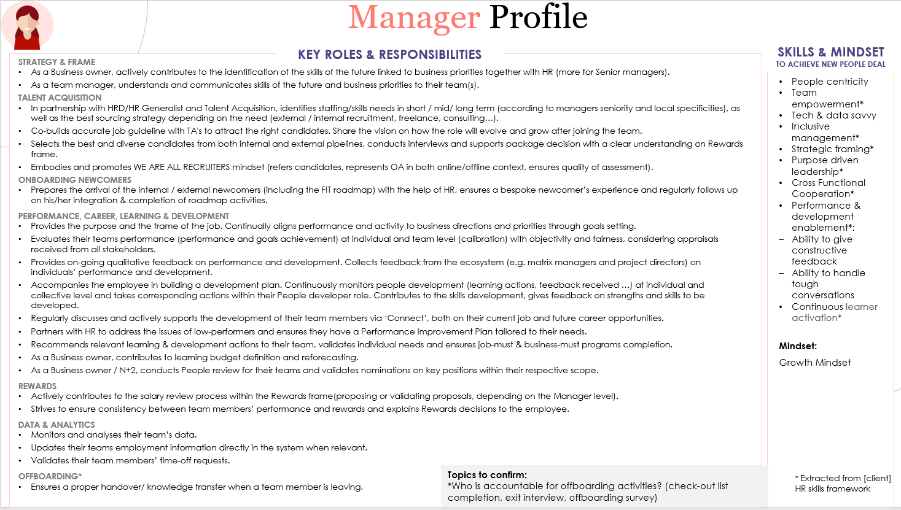One of the main challenges of HR transformation is to help ensure end-to-end transversality between processes, securing key touchpoints and roles and responsibilities consistency across the domains. We are convinced that breaking silos between streams and domains is one of the key success factors for Technicolor’s transformation project.

We propose to conduct a half-day workshop with key stakeholders—e.g., HRD, Functional leads and key local representatives—to connect the dots between the processes and help ensure overall consistency before deep-diving into detailed process and system design.

Based on the outputs from the design by domain, the purpose of this transversal workshop is to:

* Review and confirm the **overall roles and responsibilities** of key profiles: HR (generalist/specialists), managers and employees
* Validate the consolidated view **organization layers’ purpose and key activities**.

For each one of these objectives, we’ll analyze whether the target defined by domain is consistent with the HR Guiding principles and how consistent their roles and responsibilities are from a transversal end-to-end point of view.

After achieving global alignment on the high-level processes, roles and responsibilities and organization, the outputs of this phase will feed deep dive sessions to follow.

### Domain deep dive sessions and alignment

Based on the inputs from the HR future-state design workshops, KPMG will use our Powered Enterprise pre-configured full-platform Workday tenant to “jump start” the design. In the global design meetings, we’ll promote the leading practices based on the HR function future-state design and challenge you, respectfully, where you deviate from leading practice. Our goal is to help you transform how you work in HR to align the function with your business goals and mission. In general, we end with about 80 percent adoption of leading practices and 20 percent of process design tailored to client’s needs.

We have leading practices defined for many of the challenges. For example, with Contingent workforce management, we take a holistic look at contingent workers (independent contractors/free-lancers, agency workers). We recommend including these populations in Workday for reporting purposes.

This phase will be organized around two key activities:

* **Domain design deep-dive sessions**: We’ll facilitate several weeks of deep-dive process and configuration workshops. These workshops focus on the most complex processes where diving deep into the design is essential to getting the processes right. For example, we have leading practices for processes related to multiple jobs, position control, and hire.
* 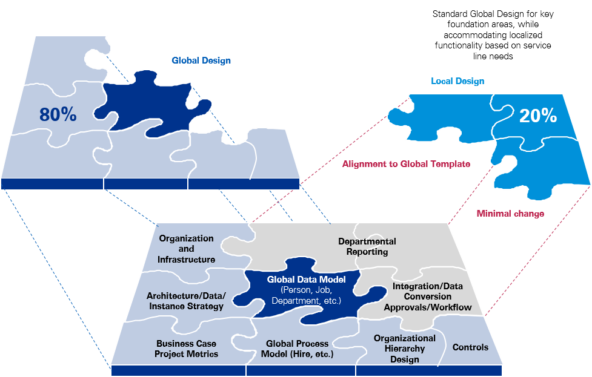**Cross-domain alignment workshop**: At the end of the Global solution design deep dive sessions per HR domain, we propose to conduct an end-to-end cross-domain workshop gathering all Functional leads to share evolution from high-level design and align on gaps.

### Local design

Once the Technicolor’s Core Model is defined, we’ll organize three regional workshops to gather local requirements. Local Functional leads will have to provide a business case should they wish to adapt the Core Model, based on legal or regulatory requirements, local business practice or economic reasons.

The local design will primarily focus on two key elements: **business process localization** and **local data.**

Workday provides many local data formats as standard (phone numbers, address…).

As part of the localization workshops, we will define which local data elements need to be collected and must not be collected for a given country (ethnicity, military status etc.).

**LOCAL DATA**

**HIGH LEVEL EXAMPLE OF HR PROCESS LOCALIZATION**

**Hiring Process localization (simplified version):** The “Local legal documents” step, which only applies to the USA, is added to collect mandatory documents at a local level (I-9 Forms, W-4 Forms…)

**Initiate**

**Compensation proposal**

**Contract Management**

Is the country USA?

**US legal documents**

**Validation**

Yes

No

Apart from data and business process localization, the **system translation** is a key component of a Global HCM system implementation project and a major driver for user adaption. We suggest the following approach:

* Translations will be introduced, and expectations and timeline shared during localization sessions.
* Unit testing will be in English to test all processes and configuration in scope.
* KPMG will provide fields (data dump) available for translation from Workday. Requirements for additional translations – including help text and custom notifications – will be completed prior to the end of Unit Testing.
* Translations to be completed by a language service provider (e.g. TransPerfect), to be contracted by Technicolor.
* Translations to be loaded and validated during End to End Testing.
* KPMG to support Technicolor to develop post-production approach to maintaining and adding additional translations as needed.

With respect to the project timeline and the constraint of system Go Live in November 2022, we propose to conduct **local design sessions** in three regions, regrouping the following major countries:

* Europe: France, the United Kingdom, Poland
* Americas: USA, Canada, Mexico
* Asia: India

We understand the translations will include French, Spanish and Polish, and Portuguese.

### Summary of Architect activities and deliverables:

| Key activities | Deliverables/outcomes |
| --- | --- |
| * Conduct AS IS assessment interviews * Analyze existing documentation * Conduct Vision workshop * Conduct high-level HR function future state workshops (by stream and transversally) * Conduct detailed solution design deep-dive sessions * Conduct local design workshops * Conduct testing strategy workshops * Conduct data model workshops * Configure the tenant * Conduct reporting strategy workshops * Prepare unit test scenarios | * AS IS analysis restitution (D) * HR Guiding principles (D) * HR end-to-end business process design (O) * Testing strategy (D) * HR organization and role profiles (O) * Workday business process transformation design blueprints (D) * Configuration design workbooks (D) * Configuration build worker data (O) * Configuration build (Prototype 1) (D) * Finalized unit test scenarios (D) * Functional and Integrations Unit Test Plan (D) * Reporting strategy and scope (D) |

*D= Deliverables O = Outcomes*

## Building and assessing your Powered Workday tenant through the Configure/Prototype/Test stage

The Configure/Prototype/Test stage is about building, testing, and refining the Workday design. This phase of the project is iterative, comprising of three prototypes and three testing cycles. Each prototype builds upon the former all the way to the Production environment. Proposed configuration enhancements are mocked up in testing environments allowing for rapid user review and acceptance. Collectively, this phase represents about 75% of the implementation timeline.

### Integrations

Integrations are among the most challenging parts of any Workday-enabled transformation. We have built more than 10,500 integrations over the past 13 years. Starting from proven designs – and not from scratch – allows our team to increase quality and reduce time-to-build, helping our clients accelerate the design conversations around these critical integrations.

Our experience suggests additional integrations may be identified during the Planning stage. We’ll work with you to not only inventory all existing integrations but also to identify and prioritize all future integrations.

KPMG will leverage Workday’s Integration Cloud platform, which is depicted in the graphic below. The platform simplifies the integration build, deploy, and monitoring activities.

**Workday’s Integration Cloud platform**

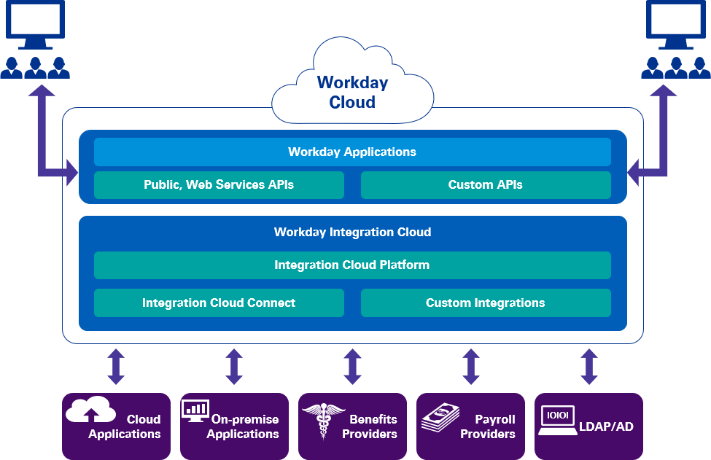

Our KPMG integration principles include:

* *Agile and Flexible*: The KPMG integration team utilizes an Agile methodology approach to managing development and testing. As appropriate, KPMG will manage sprints, run daily SCRUM calls on/offshore, and provide the necessary reporting to track visibility and status
* *Reduce and Re-use*: The KPMG integration team has an ever-growing library of standard integration templates that can be reused on each new project.
* *Knowledge Transfer and Education*: Education is key for a successful implementation. For every integration built, KPMG will transfer knowledge and documentation to the Technicolor IT team.
* *Simplicity*: We will seek to use technologies and methods for IT solutions that minimize complexity and risk.
* *Standards*: We start with Workday delivered interfaces whenever possible. This leads to a more cost-effective solution for Technicolor.
* *Tracking*: We maintain an integration log in our PES tool to capture all in-scope integrations and their status.

Our team works closely with the payroll functional teams to help ensure the payroll integrations are built to take advantage of the new configuration and to support the downstream systems.

**KPMG Cloud Integration Framework**

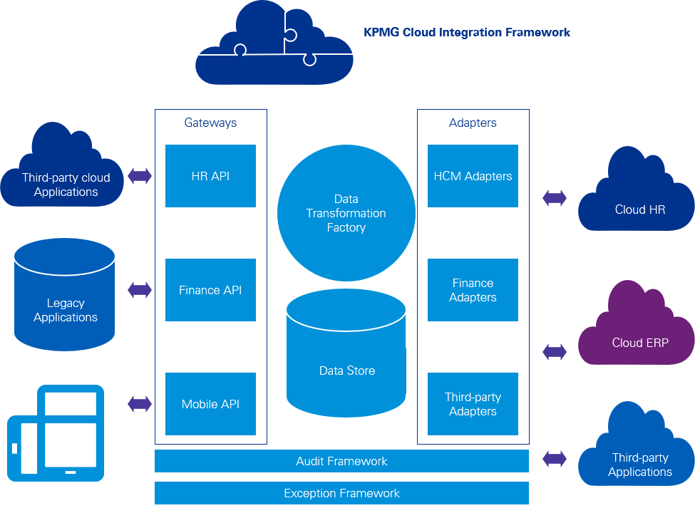

### Data conversion

During Planning, KPMG will work with Technicolor to develop a comprehensive conversion strategy to address and document the decisions around the scope and approach of the conversion to guide the Workday implementation. To make this critical step efficient and to promote data integrity, KPMG employs a number of proprietary tools, which are summarized in the table below.

|  |  |
| --- | --- |
| **Data Gathering Workbook** | * Automates the process of developing and validating Technicolor data * Provides Technicolor with a template for the various Workday data rules, accelerating the creation of data extraction/transformation logic * Contains validation checks that allow Technicolor to proactively identify and resolve data issues, reducing cost and effort of handing data back and forth * Traps errors in data * Reduces project risk by automating key aspects of the conversion process and ensures repeatability |
| **Prototype Build Tracker** | * Tracks progress of each prototype build * Allows detailed view of individual build tasks against their milestone dates * Contains built-in charts for ease of status reporting * Allows for Technicolor view into KPMG build activity to support a culture of complete project transparency |
| **Prototype Build Project Plan** | * Provides end-to-end view of tasks required to prepare for a prototype build * Allows for advanced resource planning and mitigation of conflicts * Educates Technicolor on the data conversion process |
| **Data Load Scoring Matrix** | * Tracks rates of data load success across various extracts * Summarizes volume of data errors and number of error root causes * Facilitates analysis of data quality trends between prototypes * Identifies errors that are most impactful to tenant/integration function * Prioritizes required data fields for conversion and integrations * Links to individual errors, which reduces confusion during testing * Acts as direct input into data conversion team’s scope of work for next prototype |
| **Data Conversion Audit Reports** | * Permits full audit of all data loaded * Enables direct comparison of data in Workday against data extracts |

### Reporting and analytics

KPMG will work with Technicolor to develop a reporting strategy and roadmap during the Plan phase. Our focus will not be on what reports you have today, but on what data you need to do your work and make the best decisions for your organization. We will consider different ways of accessing that data: queries, dashboards, reports. Typical areas we probe on include:

* Who needs what data? What do they need it for? Where is the data? How can they get it?
* High-level reporting tool rationalization and decision tree (when to use Workday vs. Enterprise standard tools, when is Prism Analytics a good fit, when are Workday standard capabilities a good fit?)
* Impact of security, integrations, and functional configurations on availability of and access to reports
* Building a foundation that sets up Technicolor for all levels of analytics (descriptive, diagnostic, predictive, prescriptive)

Identifying critical metrics to turn into dashboards

The insights we strive to provide Technicolor fall into four categories:

* Descriptive (what happened)
* Diagnostic (why and how it happened)
* Predictive (what will happen next)

Prescriptive (what should we do next).

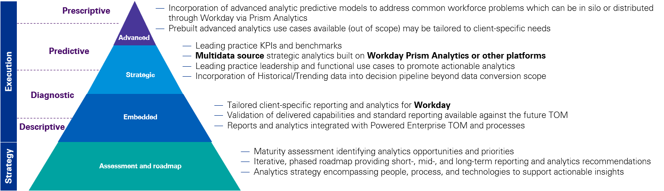

As part of this work, we will:

* Define reporting functionality that must be deployed at go-live versus functionality that can be phased in over time.
* Determine how Technicolor can access historic data that’s not converted to Workday.
* Define the best way to structure the data to support ad hoc analytics.
* Design a consistent data model for ease of use, data governance and security.
* Define the roadmap for future analytics, whether descriptive or predictive.

### Advanced analytics (artificial intelligence and machine learning)

Although out of scope for this phase, KPMG’s Digital Lighthouse center of excellence for advanced analytics has developed proprietary tools, data models, a leading and proprietary “signals” external data repository, and other thought leadership around the common problems that might be addressed via advanced analytical methods. KPMG is more than happy to work with Technicolor during the Plan phase to identify the most pressing enterprise problems that we can help you solve via advanced analytics. This will help determine where on the roadmap the deployment of such use cases should fall.

#### The KPMG difference for reporting and analytics

Reporting and analytics are areas that clients are eager to exploit through Workday. However, struggle with the end result at the initial go-live due to a lack of focus in the approach, or due to conforming to the basic “lift-and-shift” strategy of legacy reports, despite having such a critical end-user and decision impact. We find that having a strong focus on this area, and treating it as a strategic versus tactical work stream, makes a huge difference in the perceived value of Workday and is a lever for gaining buy-in.

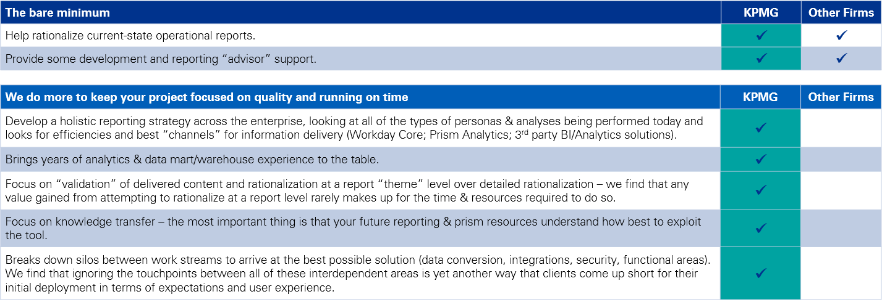

Testing

It’s important to thoroughly test the design and configuration of the Workday system. We’ll develop a robust and comprehensive testing strategy during the planning phase and apply it to each of the prototype builds. Each test cycle has a different set of entry criteria, exit criteria, conditions, and objectives.

As a collective team, we will honor the following testing principles:

* Test scenarios are not an afterthought. They’re carefully reviewed and captured during design
* Involve the right subject matter professionals in testing so that testing is thorough and precise
* Confirm test environments are stable, secure, and “ready to play” before testing begins

Engage an experienced testing lead to manage all phases of testing to help Technicolor correctly and efficiently from the onset. There should be no time wasted on “invalid” or “missed” test scenarios.

How we will test each area

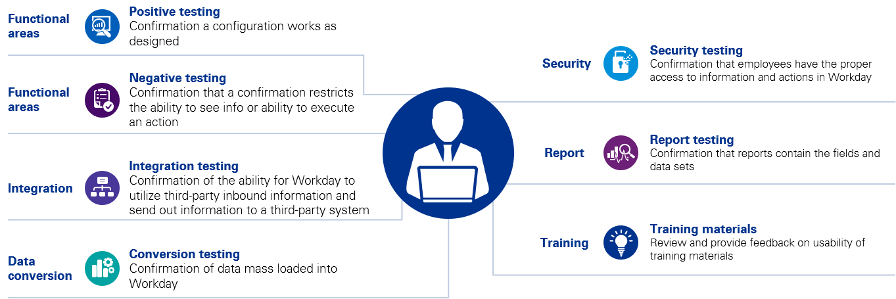

The approach will include several testing stages:

* **Smoke Testing** – KPMG will pressure test the business processes and weed out defects prior to handing over the tenant for Technicolor testing. We’ll turn over our test cases and smoke testing results (positive or negative) to Technicolor, providing full transparency into our smoke testing process.
* **Functional Unit Testing** – Our KPMG testing advisor will guide the Technicolor team through reviewing, evaluating, and testing the Workday system configuration and business process design after each prototype build. In addition, our functional consultants will familiarize the Technicolor team with Workday during the first week of testing by going through Hire-to-Retire processes.
* **End-to-End Testing** – During this testing cycle, Technicolor will test business processes and integrations from beginning to end to mimic real life operational processes. This testing cycle will occur during your second prototype. We leverage both structured and “Day in the Life” testing to capture all scenarios and fully assess integration with systems touching Workday. This is also an opportunity to check the configuration, security setup and role assignments along with testing business critical reporting
* **User Acceptance Testing (UAT)** – In this testing cycle, a small group of Technicolor end users who are not part of the core Technicolor project team will execute common transactions in Workday. This provides critical feedback on the training materials and online support resources. This “dress rehearsal” prepares your team to hit the ground running from call intake through escalation and issue resolution.
* **The KPMG Powered Enterprise approach** to testing involves several key facets to allow for efficient testing which quickly familiarizes key project team members with the system, while simultaneously performing a confirmation of configuration to help ensure Technicolor’s needs are met.
* **Employs testing scenarios, as opposed to scripts**. We have invested in a comprehensive library of testing scenarios that we will leverage during this stage. We find test scenario development is often an overlooked component of client resource utilization, and we’ve found our library will allow our clients’ teams to focus on the scenarios that are specific to your business rather than spending time on scenarios that all clients will run.
* **Leverages testing as an opportunity** **to train** key support resources and create buy-in for the project. Being deliberate about who is involved as a tester from Technicolor will help surface design changes early on and ease training requirements prior to go-live.
* **Leans on PES**to track testing and report results. KPMG has developed a tenant management approach that allows us to maintain multiple tenants in synch during each stage of testing. This is an important differentiator for us, as we can maintain the integrity of all testing cycles, including overlapping cycles.
* **Standardizes priority levels for defects across all testing cycles**. Priority Levels are used to define the importance of the identified issue, both in terms of the impact to testing and the impact the issue would have if the application were released without resolution of the issue. It is critical to define clear defect priorities as this creates continuity between testing cycles and helps unify understanding of criticality between the project team and testers. Our testing lead will work with your team to define agreed upon priorities while developing the overall testing strategy during the planning phase.
* **Establishes a uniform defect management process** allows for timely resolution and implementation of any configuration changes to move closer to meeting the exit criteria for that testing cycle. We will work with Technicolor to solution the best defect management process for the team. An example of a successful defect management process can be seen below.

Defect management process

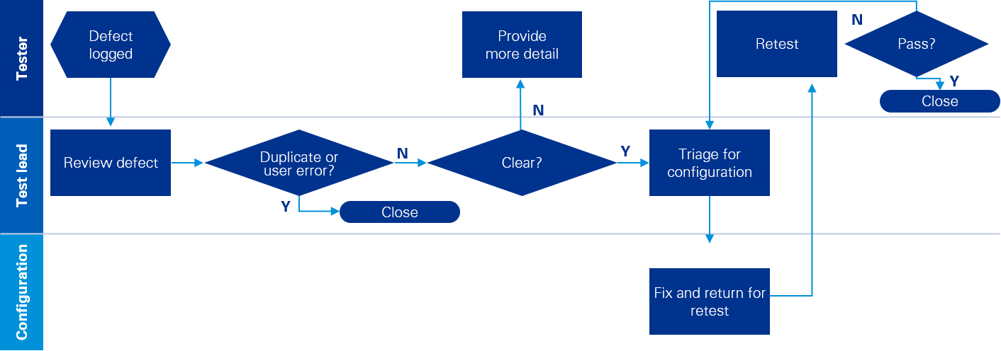

To accelerate the testing process, we’ll use:

|  |  |
| --- | --- |
| **Powered Execution Suite (PES) JIRA** | * PES (Jira) is leveraged to provide a consolidated and automated place to track all elements of a successful testing cycle * Allows the project team to track all scenarios related to that testing cycle and any issues or defects that were identified during the testing cycle |
| **Sample unit test scenarios** | * Library of pre-built unit test scenarios for all modules in scope. Mapped to leading practice business processes * Provides starting point for testing scenarios, saves time in testing effort |
| **Testing status dashboards** | * Pre-built dashboards in PES used for tracking daily testing status, outstanding items, and scenario owners * Enables testing cycles to stay on track, establish ownership, and status is communicated appropriately throughout |

### Summary of Configure, Prototype, and Test activities and deliverables:

| Key activities | Deliverables/outcomes | |
| --- | --- | --- |
| * Conduct Customer Confirmation Sessions * Conduct and complete unit testing * Resolve logged defects * Log, mitigate, and re-test any change requests * Achieve End-to-End (Prototype 2) build signoff * Obtain worker data for End-to-End build * Complete End-to-End build * Conduct and complete End-to-End testing * Conduct and complete User Acceptance Testing (UAT) * Complete integration design and development * Establish change agent network | * End-to-End build worker data (D) * End-to-End (Prototype 2) build (O) * End-to-End build data validation reports (D) * Integrations built (O) * Reports built (O) * Finalized End-to-End test scenarios (D) * End-to-End test plan (D) * End-to-End test results (D) * Finalized UAT test scenarios (D) * UAT test plan (D) * UAT test results (D) * Leadership action plans (D) * Organizational readiness recommendations (D) * Change management and communication materials (D) * Change agent network materials (D) * Final training curriculum (D) * Training materials (D) * Pre-production (Gold) build worker data (D) * Workday Go Live checklist (D) * Dual data entry into legacy systems and Workday during cutover (O) * Hypercare plan (D) * Knowledge transfer sessions (O) * Training delivered (O) |

*D = deliverables O= Outcomes*

## Deploy implementation stages

During the Deploy and Go-Live stages of the project, KPMG and Technicolor will execute the steps necessary for moving your system into the production environment. This includes completing final configuration, loading, and validating employee data, and migrating integrations and custom reports.

Before we can move to the go live date, KPMG and Technicolor will be required to complete the Go-Live Checklist to confirm preparedness for cutover. The purpose of cutover is to help ensure that:

* Required information is accurately converted and loaded into the system
* Users are trained
* Support systems are engaged
* Legacy systems are retired or repurposed for utilization as appropriate; and
* Transition to production services is completed

To support Go-Live, KPMG emphasizes the following aspects of deployment:

* Design of your Workday operational team
* KPMG will help Technicolor plan and execute detailed and thorough organizational and production readiness (dress rehearsal) workshops. These workshops have allowed our clients to be significantly prepared for transitioning into production.
* The purpose of these workshops is to help Technicolor prepare and organize for go live support and to reach a business as usual state. This is not technical or solution testing phase, it is an organizational readiness and support model validation exercise with heavy inputs from change management or training teams.
* The Workday system is supported by Technicolor’s support organization with clear roles and responsibilities defined for Tier 1, Tier 2, and escalation roles defined.
* Infrastructure such as systems (for e.g., Workday Help) used to collect support tickets, call centers with phone/email contact information are identified and tested prior to deployment.
* Integration with other applications and downstream systems are seamless and effective.
* Validating knowledge transfer and testing resources ability to answer questions based on the new system and ability to leverage training material to resolve issues in a timely manner.

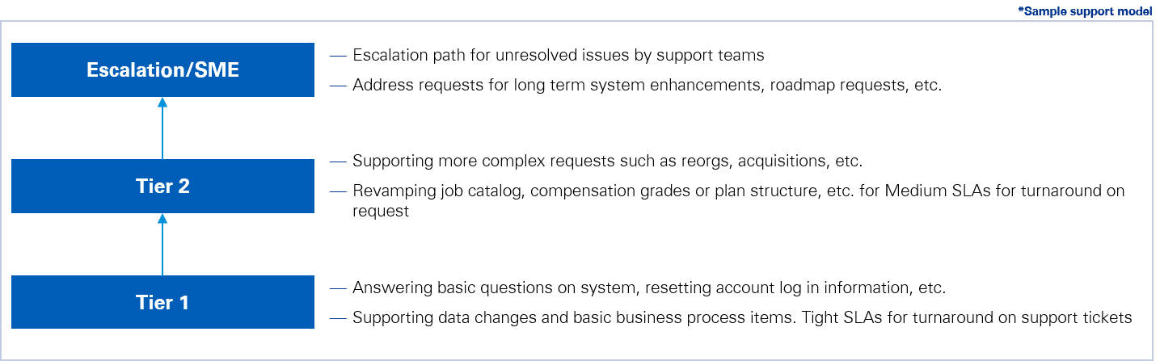

The goal of these business as usual workshops is to equip the Technicolor support team with clear roles and responsibilities defined for Tier 1, Tier 2, and escalation support resources. KPMG will partner closely with Technicolor to help you get to a mature support model in an accelerated timeline. Sample Tier Escalation Process.

In the Deploy stage, the focus is on:

* **Knowledge transfer**to your team throughout the project so Technicolor resources are trained and ready to manage the system. KPMG follows an “active” knowledge transfer methodology so Technicolor is ready and prepared to switch to the new technology.
* **Developing a comprehensive Cutover plan**that effectively manages dependencies, tasks, and data and teams for a smooth final transition from Legacy to Workday. KPMG will bring our proven library of cutover tasks and cutover toolkits that are continuously updated based on key lessons learned from our global system cutovers for large, complex organizations.
* **Catching up the tenant** during go-live is critical. KPMG will work with Technicolor to define a catch-up approach that allows Technicolor users to essentially pick up with Workday exactly where they left off with legacy system from a business perspective. A solid catch-up plan will translate to minimal impacts to business users. KPMG will provide Technicolor with a series of templates that we have developed to take out the EIB guesswork and reduce the data conversion manual work.
* **Hypercare and post go-live support** is continued through the first month post go-live. At this point KPMG will be assisting Technicolor with any critical production issues that arise as well as providing over the shoulder help to assist Technicolor end users in troubleshooting issues and conduct any remaining knowledge transfer.
* **Providing ongoing support**, including support for issue identification, system optimization, and deployment of additional/improved functionality. We will work with Technicolor to scope ongoing support appropriately prior to go-live, if needed.

To accelerate the Deploy work, we’ll use:

|  |  |  |
| --- | --- | --- |
| **Client Workday Support Model Framework** | * Used to accelerate the design of the Technicolor post-production Workday support team * Based on industry-leading support structures across numerous KPMG clients | |
| **Temporary “skinny” Business Processes** | * These are used to quickly load catch up data without the need for approvals typically needed when entering data directly into the user interface |
| **Catch Up EIB Templates** | * Used for go-live data catch-up and post go-live mass transactions * Permits version of existing extraction and transformation process to be used for catch-up, reducing manual effort | |
| **Go-Live Checklist and Cutover Plan** | * Pre-built, extensive task plan that tracks necessary cutover tasks and dependencies * Mitigates risks associated to the go-live event by aligning technical and functional areas, and tracking key touch points with internal and external stakeholders (e.g., integration vendors, IT security) | |

### Summary of Deploy activities and deliverables:

| Key activities | Deliverables/outcomes |
| --- | --- |
| * Conduct final knowledge transfer sessions * Create Data Catch-Up Plan * Extract Data for Gold / Production Build * Initiate and support the training delivery program * Provide Gold/ Production Build Data to KPMG in Consolidated Workbook * Conduct Go/No Go Meeting * Convert and Load Production Build * Validate Production Build * Migrate Integrations into Gold Tenant * Extract Data for Catch-Up * Conduct Data Catch-Up * Complete Workday Go-Live Checklist * Execute Transition to Production Plan * Coordinate and Perform Go-Live Activities * Provide Hypercare (Post-Production) Support | * Knowledge Transfer Checklists (D) * Data Catch-Up Plan (D) * Cutover Strategy (D) * Cutover Plan (D) * Go-Live Checklist (D) * Gold Tenant Configured, System Built and Deployed to Production (O) * Production Support Knowledge Transfer Final Checklist Ratings (D) * Post Go-Live Support (O) |

*D = deliverables O= Outcomes*

## E. Post-implementation support and knowledge transfer

Every aspect of our Powered Enterprise approach is focused on building Technicolor’s capability to be self-sufficient after go-live. We place a significant emphasis on the pre- to post-production transition plan.

Key KPMG project leads will support the Technicolor team for a period of four – six weeks immediately after the go-live date. During this period, KPMG is responsible for providing over-the-shoulder support to triage identified issues within the Production environment and, in the process, conducting on-the-job knowledge transfer to Technicolor resources. After the period of Hypercare Support, Technicolor resources will be fully prepared to maintain and support the system going forward.

| KPMG provides extensive support as you transition to your system. In fact, our support typically is more comprehensive than what our competitors include, because we know how critical this part of the implementation is to long-term success. We believe our standard methodology includes more time and effort than anyone in the business. |
| --- |

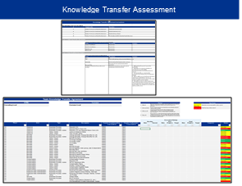Our approach to knowledge transfer has two key elements: 1) Two-in-a-box staffing and 2) See One-Do One-Own One. First, we staff our projects so that our SMP and your lead are “two-in-a-box.” They share the responsibility for that work stream and work shoulder-to-shoulder from project start to finish. Second, your lead watches how we solution/configure/test on Prototype 1, sharesthe work with our SMP in Prototype 2, and then owns the work beginning in Prototype 3, with our SMP observing and coaching to help your lead become proficient in the work.

In addition to the core project team, we involve key stakeholders from across the organization in design, testing, and deployment. This involvement creates a network of change champions who understand the system, why it was designed and configured a certain way (e.g., per leading practices), and how it will benefit the organization. These change champions create a broad base of support for the new way of working for two reasons: people know them, and people trust them.

Our approach to knowledge transfer results in your team being self-sufficient by project end and ready to support Workday after KPMG leaves. It also promotes broad and consistent adoption of the new way of working.

Our goal is to provide your team with the knowledge and understanding to maintain Workday and its dependent systems once the engagement is complete.

|  |  |
| --- | --- |
| **Accelerators** | **Description** |
| **Knowledge Transfer Checklist and Education/Validation Decks (by functional area)** | Knowledge Transfer checklists, by functional area, used to facilitate final KT; helps ensure the team can administer/maintain system on its own; materials are leave-behind for Technicolor. |
| **Integration KT checklist** | Detailed and comprehensive checklist to help ensure proper knowledge transfer between KPMG integration system developer and future Technicolor responsible party. |

## Program team roles and commitments

Given Technicolor’s large global footprint and anticipated multi-country deployment approach, we recommend a centrally led organization to HR transformation activities. However, it is key to involve local representatives (e.g., country HRDs), as well as end-users to help ensure the design is consistent and test its relevancy for business and local context. These representatives would participate in design sessions and return to test the developed solution.

The following table highlights a high-level view of key roles and anticipated workload over the project. We’ll complete a detailed staffing plan of Technicolor and KPMG roles as part of the creation of the statement of work.

| Role​ | | Description​ | Expected commitment​ |
| --- | --- | --- | --- |
| **Project Sponsor/Steering Committee**​ | Overall strategy and direction, key decisions. Executive sponsorship, remove barriers for the team.​ | 5-10%​ | |
| **Program Lead(s)/Operating Committee**​ | Responsible for overall Scope, Budget, Schedule, Risks/Issues, Communication & Quality of the project. Promotes collaboration and communication between the departments and the work streams, ensuring all groups are working together. Assist with decision making and ultimately tasked with reporting to the Steering Committee.​ | 10-15%​ | |
| **Project Manager**​ | Provides the engagement team with day-to-day direction and leadership. Manages the work plans associated with the project charter/scope of work, including resource commitments and scheduling, and managing tasks required for successful execution. ​ | 80-100%​ | |
| **Testing Management**​  *Testing Lead, Testers*​ | **Lead** – Leads the testing management for an engagement. This includes delivering the test strategy and plan, coordinating the accumulation and update of test scenarios, coordinating test scenario execution, managing defect and change request items, coordinating and reporting on testing results, and ensuring that the test event entry/exit criteria are defined, accepted and achieved.​  **Testers –**Carry out the execution of test scenarios, monitoring and re-testing defects and change requests as required.​ | 50-80%​ | |
| **Change Management & Communication**​  *Lead, Communication Team*​ | **Lead –**Responsible for producing and executing the change management and communications strategy and plan.​  **Communication –**Delivers the communication strategy and implements the communications plan setting out the principles to be adhered to and the roles and responsibilities amongst the program team. ​ | ~50%​ | |
| **Training**​  Lead, Developer, Facilitator​ | **Lead –**Responsible for producing and executing the training strategy and plan.​  **Developer –**Responsible for the design, development and delivery of training materials/content for the new processes and system for end users. **Facilitator** - Responsible for hosting classroom sessions with identified end users.​ | ~50%​  Varies by role​ | |
| **Functional Leads**​ | Day‑to‑day leads responsible for managing the daily activities for their process area driving toward quality completion of deliverables. Also responsible for tenant configuration, testing, coordination with business owners on design and integration functionality. Owns issue resolution in their individual process area to make sure technology meets the business needs for the process area.​ | ~60%​  Varies by area​ | |
| **Subject Matter Experts**​  *As needed: Business Process, IT, Localization*​ | Brings significant knowledge on a particular set of process and industry issues to the team to help address particularly challenging designs or other open issues. Typically participates on a part-time basis, or full time during discrete phases of work. Representative of country-specific P&T representation during localization sessions.​ | ~20%​ | |
| **Technical Lead**​ | Responsible for the technical portion of the project. Enacts strategy and supports day-to-day execution end-to-end throughout the project.​ | ~20%​ | |
| **Technical Functional Lead**​ | Leads the design and development of each particular technical area (e.g., Integrations, Data Conversion, Security). Collaborates with Functional Leads to ensure needs are met, and collaborate to resolve issues.​ | 80-100%​ | |
| **Integration Developers**​ | Responsible for designing, building, and unit testing of required integrations. Support end to end integration testing.​ | 80-100%​ | |

**Recommended program team structure**

The following represents our recommended program team structure.

